**Evolution Changes**

The following changes apply to those Pokémon who were unable to evolve on a ROM i.e Trading Pokémon.

Some Pokemon now evolve at a higher level due to stat increases i.e Zigzagoon, Taillow etc.

Rare Candy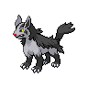

**Lv. 25**

**Rare CandyRare Candy**

**Lv. 15 Lv. 25**

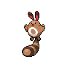**Rare Candy**

**Lv. 24**

**Rare CandyRare Candy**

**Lv. 25 Lv. 36**

**Rare CandyRare Candy**

**Lv. 25 Lv. 36**

**Rare CandyRare Candy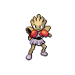Rare Candy**

**Lv. 34 Atk > Def Lv. 34 Def > Atk Lv. 34 Atk = Def**

**Rare CandyRare Candy**

**Lv. 36 W/high Personality Lv. 36 W/low Personality**

**(Completely Random)**

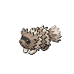**Rare Candy**

**Lv. 26**

**Rare Candy**

**Lv. 28**

**Rare Candy**

**Lv. 28**

** Rare Candy**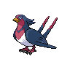

**Lv. 32**

**Rare Candy**

**Lv. 32**

**Rare Candy**

**Lv. 32**

**Rare Candy**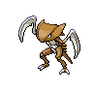

**Lv. 32**

**Rare Candy**

**Lv. 32**

**Rare Candy**

**Lv. 32**

**Rare Candy**

**Lv. 32**

**Rare Candy**

**Lv. 40**

**Rare Candy**

**Lv. 43**

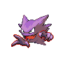**Rare Candy**

**Lv. 44**

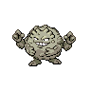**Rare Candy**

**Lv. 45**

**Rare Candy**

**Lv. 45**

**Rare Candy**

**Lv. 46**

**Rare Candy**

**Lv. 47**

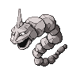**Rare Candy**

**Lv. 47**

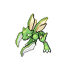**Rare Candy**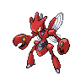

**Lv. 47**

**Rare Candy**

**Lv. 48**

**Rare Candy**

**Lv. 48**

**Water Stone**

**Item: Water Stone**

**Water Stone**

**Item: Water Stone**

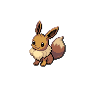**Moon Stone**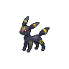

**Item: Moon Stone**

**Sun Stone**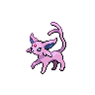

**Item: Sun Stone**

**Item Changes/Additions**

* **Lucky Egg** from the Swimmer outside Fuchsia City Gym
* **Thick Club** from the Chef in Fuchsia City
* **Silver Powder** from the Lady near the Gym in Celadon City
* **Sharp Beak** from the Delivery Man in Saffron City
* **Poison Barb** from the Gentleman in Saffron City
* **Spell Tag** from the Woman outside the Pokémon Tower
* **Stick** from the Assistant at the entrance of Vermillion City
* **Light Ball** from the Old Woman outside the Vermillion City Gym
* **Twisted Spoon** from the man standing north of Route 19
* **Dragon Fang** from the Guy in Pewter City
* **Black Belt** from the Karate Master in Pewter City
* **Mystic Water** from the Swimmer in Pewter City
* **Soft Sand** from the Sailor in Cerulean City
* **Magnet** from the Girl in the Centre of Cerulean City
* **Metal Powder** from the Biker in Celadon City
* **Old Rod** from the Assistant in Viridian City
* **Mental Herb** from one of the Chansey in the Pokémon Centres
* **Choice Band** from one of the Chansey in the Pokémon Centres
* **Shell Bel**l from one of the Chansey in the Pokémon Centres
* **Nest Balls** from one of the Chansey in the Pokémon Centres
* **Scope Lens** from one of the Chansey in the Pokémon Centres
* **White Herb** from one of the Chansey in the Pokémon Centres

**Attack Changes**

**Normal**

Cut Power of 60

Weather Ball Power of 75

Covet Power of 60

Swift Power of 65 PP of 35

Strength Power of 85

Wrap Power of 30

Endeavour PP of 10

Facade Power of 80

Pay Day Power of 60

Extremespeed Power of 90

Constrict Power of 35

**Fighting**

Triple Kick Power of 25

Sky Uppercut Power of 90

Revenge Power of 70 PP of 15

Arm Thrust Power of 25

Brick Break Power of 80 PP of 20

**Fire**

Fire Spin Power of 45

Blaze Kick Power of 90 PP of 15

**Bug**

Silver Wind Power of 70 PP of 15

Signal Beam Power of 80

Twineedle Power of 45

Fury Cutter Power of 25

Pin Missile Power of 32

**Grass**

Bullet Seed Power of 25

Giga Drain Power of 75 PP of 15

Absorb Power of 30 PP of 25

Mega Drain Power of 55 PP of 20

Needle Arm Power of 75 PP of 20

Leaf Blade Power of 90

**Water**

Dive Power of 70 PP of 15

Whirlpool Power of 50

Waterfall Power of 85 PP of 20

Bubblebeam Power of 70

Water Pulse Power of 75

Muddy Water Accuracy of 90

Clamp Power of 40 Acc. of 90%

**Rock**

Ancient Power Power of 70 PP of 15

Rock Slide Power of 80 PP of 15 Acc. of 100%

Rock Smash Power 45

Rock Tomb Power of 60 Acc. of 95%

Rock Blast Power of 30

**Flying**

Razor Wind Power of 90 PP of 15

Bounce Power of 95, PP of 10 Acc. of 100%

Air Cutter Power of 65

Aerial Ace Power of 80 PP of 25

Drill Peck Power of 90

**Ground**

Dig Power of 75

Mud-Slap Power of 40

Bone Club Power of 70

Bonemerang Power of 60

Bone Rush Power of 45

**Electric**

Thundershock Power of 50

Spark Power of 70 PP of 25

Shock Wave Power of 70

**Steel**

Iron Tail Accuracy of 85

Metal Claw Power of 65

Meteor Mash Accuracy of 100

**Dark**

Pursuit Power of 50

Faint Attack Power of 70

Crunch Power of 90

Theif Power of 60 PP of 15

**Psychic**

Psychic Power of 95

Extrasensory Power of 85

Psybeam Power of 70

Confusion Power of 55

**Ghost**

Lick Power of 30

**Poison**

Smog Power of 35 Acc. of 85%

Poison Fang Power of 80

Poison Tail Power of 65

**Dragon**

Dragonbreath Power of 80

Dragon Claw Power of 90

Twister Power of 60

**Ice**

Powder Snow Power of 50

Icy Wind Power of 70

Icicle Spear Power of 20

**Ability Changes**

** **

**Cloud Nine**

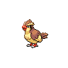 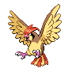 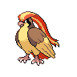

**Pressure**

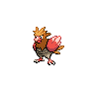 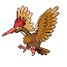

**Keen Eye/Hustle**

** **

**Rain Dish**

** **

**Natural Cure**

 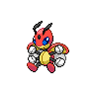

**Natural Cure**

 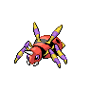

**Effect Spore**

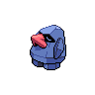

**Vital Spirit**

** **

**Sturdy**

**[](http://pokemondb.net/pokedex/aron)[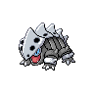](http://pokemondb.net/pokedex/lairon)[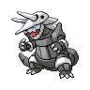](http://pokemondb.net/pokedex/aggron)**

**Battle Armor**

**[](http://pokemondb.net/pokedex/machop)[](http://pokemondb.net/pokedex/machoke)[](http://pokemondb.net/pokedex/machamp)**

**Limber  
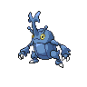**

**Compound Eyes  
 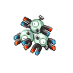**

**Levitate**

** **

**Levitate**

** **

**Compound Eyes**

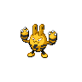 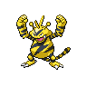

**Volt Absorb**

** **

**Swift Swim**

** **

**Cute Charm**



**Own Tempo/Early Bird**



**Speed Boost/Intimidate**



**Overgrow**

** **

**Torrent**

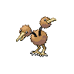 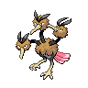

**Huge Power**

**[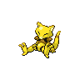](http://pokemondb.net/pokedex/abra)[](http://pokemondb.net/pokedex/kadabra)[](http://pokemondb.net/pokedex/alakazam)**

**Pressure  
  **

**Insomnia**

 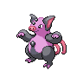

**Trace**

** **

**Battle Armor**

** **

**Drizzle**

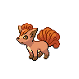 

**Drought**

 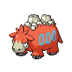

**Huge Power**

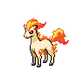 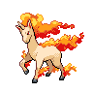

**Speed Boost**

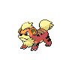 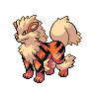

**Flame Body**

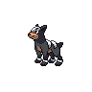 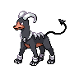

**Flash Fire/Intimidate**

**Gym Leader Rematches**

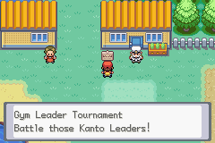

You can rematch the Gym Leaders at the House in Vermillion City.